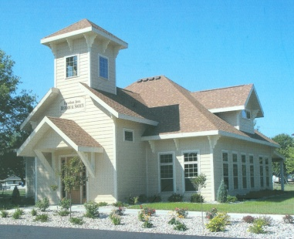

**Freedom Area Historical Society (FAHS) Newsletter Spring 2013**

**Serving the Towns of Center, Freedom, Kaukauna, Oneida & Osborn**

**OPEN HOURS**

**Wednesdays and Thursdays 10:30 – 5:30**

**Saturdays 10:30 – 12:30 Or by Appointment**

**920-423-3036 Email:** [**fahs@newbc.rr.com**](mailto:fahs@newbc.rr.com)

**Free Admission - Donations are appreciated**

**N4045 McHugh Rd**

**Freedom, WI 54130**

**Please join us for the Eighth**

**ANNUAL MEETING**

**Tuesday April 16, 2013 - 6:30 P.M.**

**At the Freedom Area Historical Society (FAHS) on McHugh Rd**

**Review of the Past Year**

**Election of Board Members**

**Election to fill 2 expired terms will take place at the meeting.**

**All 2013 members, 18 or older, who have paid their dues at least 30 days prior to the annual meeting are eligible to vote in the election of board members on April 16, 2013.**

**Nominations For the Board Are Welcome**

**If you are interested in serving on the board, please contact the Historical Society.**

**SPECIAL PROGRAM**

**Immediately following the meeting!**

**Gene & Virgie Janssen will talk about how to interview people about**

**their life experiences. The will conduct a mock interview to show our board**

**and our members how to interview and how to help make the**

**interviewee comfortable. This instruction will tie in nicely with our new**

**Oral/Video History Project**

**C:\Documents and Settings\User2\Local Settings\Temporary Internet Files\Content.IE5\T6W9OY4K\MC900383698[1].wmf**

***Come early & enjoy all of our displays***

***Actual meeting runs about 30 minutes***

***~ ~ Refreshments will be served ~ ~***

**Highlighting Our Families**

**This display has been very well received by family members and visitors.**

**Many of you have visited the Historical Society to learn more about the families.**

**We have made one change for 2013. That is, we will display each family for two months, rather than one month. We hope this will allow more people to find time to see the displays. Since the last newsletter was published, we’ve highlighted the following families:**

**FOX, SPIEGEL, & EBBEN**

**Peter Fox (b. 1837 d. 1913) was first married to Anna Shomer/Schomer, who died in the mid 1860’s. He then married Margret Hein. Peter had 6 children; Nicholas B. (Alexandria Huss), Elisabeth (Mathias Lanser), Mary (Vincent Meyer), Peter F. Fox (Nellie Kortz), Rosa (James Hooyman) and John (Carrie Hoks). Peter & Margret owned 80 acres in section 21, Town of Freedom, where they farmed. Peter’s oldest son, Nicholas, and his wife Alexandra, farmed in the Town of Freedom on County Road UU. Their children are Elizabeth Haney, Margaret Rutter, Adeline Daul, Mary Murphy, Nick, Laura Deering, Helen Lamers, Kitty Lamers, & Joe. Joe (Adeline (Grode) Fox took over the farm on County Road UU from his parents, Nicholas & Alexandra.**

**Joe & Adeline’s children are; Pat Lorenz, Barb Wagner, Don, Ann Mueller, Linda Hattou and Rita Schilcher Fox. Don Fox & his wife Jean (Vande Wettering) took over Don’s parents’ farm on**

**County Road UU. Marvin Fox, son of Nick & Lucille (Baumann) Fox and grandson of Nicholas B. Huss, farmed on County Road J in the Town of Kaukauna, where he and his wife, Audrey (Brittnacher), still reside. Marvin & Audrey’s children are; Gary, Greg, Robert, Richard, Daniel,**

**Lynn Schmeichel, Susan Konkle, Joan Maloney and Mary Rafferty.**

**Harlin and Dee (Gossen) Spiegel moved to Freedom in 1957.**

**Their children are; Sherri (Phil) Devins, Rick (Linda), Jan (Terry) Zimmerman, and Donna (Michael) Arndt. Harlin’s parents are Aloys and Bernice (Beckman) of Dale, Wisconsin. Harlin worked in the printing industry for 42 years. Dee (Gossen) Spiegel is on the Town of Freedom Plan Commission.**

**She also manages Freedom’s Senior Meal Program.**

**Arnoldus & Johanna (Ermers) Ebben came to America from the Netherlands in 1848.**

**Their children are; Peter, Hermanus “Herman”, Willem, Johannes, Hendrickus & Hendrina. They settled in the Town of Kaukauna. Son, Herman & his wife, Johanna “Anna” (Vanderlinden), farmed in the towns of Freedom & Kaukauna, on County Road J, near County Rd S. When they retired from farming, Herman and Anna moved to the village of Freedom where they lived on the corner of County Road S & Coffey Street.” Herman & Anna’s children are; Delia Hooyman, Martin, Peter, John, Mary, Jacob, Henry, Minnie West and Clara Van Dyke. Peter Ebben (son of Herman) married Kate Baumgartner and farmed on County Road J near his parents. They had one foster child, Mary Huven. John Ebben (son of Herman) married Anna Vandenberg. Their children are Henry(who married Mary Huven), Johanna, Jennie, Mary, Herman, Annie, Gerard, John, Helena, Raymond and Aloysius. Jacob Ebben (son of Herman) married Nellie West and farmed on the homestead of his father on County Road J in the Town of Freedom.**

**Below are the family surnames that will be highlighted during the rest of 2013**

**March & April - Ebben May & June - Fiestadt**

**July & August - Umlauft Sept. & Oct. - Schwalbach**

**Nov. & Dec. - Arnoldussen**

**Lime Rock Settlement in Town of Osborn**

**The following information is based on information in *The Osborn Almanac***

**by Oliver Lerum (also known as Osborn Ollie)**

**The Town of Osborn was established in 1859 when it split off from the Town of Freedom.**

**At that time, the Town of Osborn included what later became the Town of Seymour.**

**Lime Rock was located at the corner of French Rd and State Road 54.**

**In 1849, Thaddeus McCormick and his grown sons were the first to settle in Osborn at what would later be named Lime Rock. In 1850, Robert McNab also settled at Lime Rock.**

**By 1858 a Methodist church was built in Lime Rock. (In 1875 the Methodist church was**

**moved to the Town of Seymour.) The same year that Osborn became a town (1859)**

**Appleton merchants donated $100 toward improving the road between Lime Rock and Appleton because they wanted the settlers’ trade. In 1860 Mrs. George Shepherd was given**

**the privilege of naming Lime Rock, a fitting name because of the limestone found there.**

**At Lime Rock in 1860, you could purchase tools, dry goods**

**and groceries, eggs $.10/doz., butter $.12 per pound, and kerosene ($.80).**

**Also in 1860, a log schoolhouse was built at Lime Rock, south of the limestone quarry on French Road. This was the Town of Osborn School District No. 2 and served all of what is now the Town of Seymour and part of the Town of Osborn. The first teacher was**

**Mrs. Frank M. Manley. She held school under shade trees until the school house was built. The school served as Sunday school, church services, town meetings & public gatherings. In 1869, this school district was dissolved and a new district formed.**

**The new district built their school one half mile south of the original school,**

**where Osborn’s present Town Hall sits. The 1860 log schoolhouse was sold**

**for $28.66 and used as a church.**

**In 1865, Willis Munger was named Postmaster at Lime Rock, his salary being $9.00 per year. In 1865, David Benedict built a log home at Lime Rock. Travelers got room and board there. Indians traded maple sugar for other food. David Benedict quarried limestone, built Kilns and made lime (CaO), butchered and peddled meat. He also founded The United Brethren Church which was built half a mile east of Lime Rock. Many of the preachers stayed at the Benedict home. In 1867 a Methodist Episcopal Church formed at Lime Rock. Also in 1867, the Town of Seymour formed and separated from the Town of Osborn. In 1871, the Green Bay & Lake Pepin Railroad was completed through Seymour. This spelled the beginning of the end for the Lime Rock settlement, because the railroad had to follow the contour of the hill, west of**

**Lime Rock!**

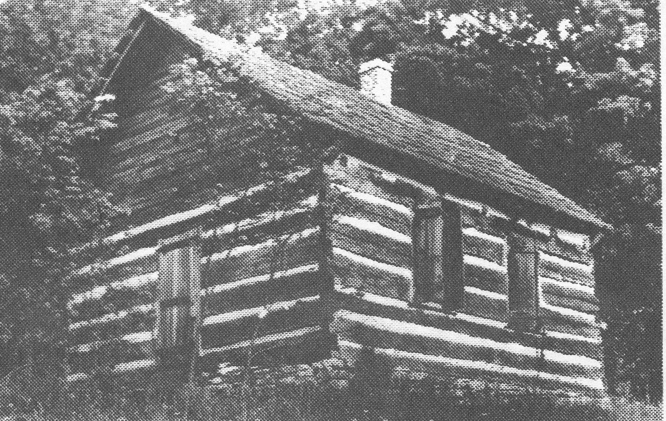

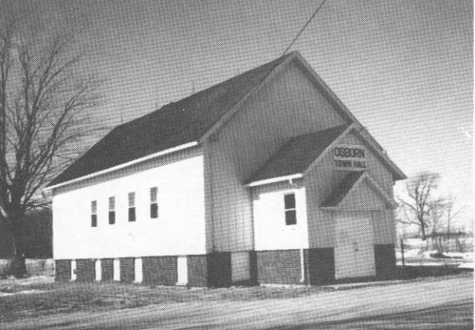

**Present Osborn Town Hall Osborn School District No. 2**

**Southeast corner of French Rd. & Blohm Rd. (1860-1869)**

***Monetary Donations received since the last Newsletter***

***We Appreciate your Generosity & Support***

***$ 10 – per month from Mary Mauthe $ 100 Gift Card – Brenda Fritsch***

***$ 50 – Gene Gonnering $ 90 – Barbara Bell***

***$ 25 – Jack & RuthAnn Smith $ 15 – Mary Ellen Kavanaugh***

***$ 100 – Tom Smith $ 20 – Shirley Primavera***

***$ 50 - Thrivent Financial on behalf of Diane M. Geurts***

***$10,000 – Weyers Family Foundation for ‘Freedom Pursuit’ ads & other needs***

**The Historical Society relies on donations, membership, & fundraising to operate!**

**THANK YOU**

**To all of our supporters who have Donated or Loaned**

**Their Time & Treasures to the FAHS since the last Newsletter was printed**

**Quentin & Audrey Thede Denise Veldman Marilyn Van Handel**

**Mary Lom Susan Powers Marv Haberland**

**Florence Vanden Heuvel Helen Van Epern Mary Van Den Bosch**

**Jeanne Helein Rosie Roskom Mary Jane Vande Loo**

**Linda Van Den Bosch Kenny Vandenberg Nathan Van Den Bosch**

**Judy Van Den Bosch Jack Nienhaus Rick Pynenberg**

**Dick Vanden Berg Jane Van Asten Mary Ellen Kavanaugh**

**Margaret Ann Randerson JoAnn Bowers Tom Smith**

**Bill Moehring Ann Weyenberg Dan & Charlotte Vandenberg**

**Jeanne Greenwood Pat Konkle Keith Roskowski**

**There are Many Ways You Can Support the Historical Society**

**~ Become a Member ~ Become a Board Member**

**~ Volunteer to help with Displays ~ Make a Financial Donation**

**~ Volunteer for work using Computers ~ Give a Memorial Gift on behalf of**

**~ Volunteer to be Interviewed or to a loved one**

**interview others ~ Provide for gifting to FAHS in your Will**

**~ Volunteer to help with Fundraising ~ Donate or loan your Vintage Items**

**~ Volunteer to help Clean our building ~ Donate your Family history, Club or**

**~ Volunteer for Handyman services Organization history, Town, School or**

**~ Attend the Annual Meeting in April Church history, as well as Photos**

**Historical Society SPRING FUNDRAISER**

***Homemade BAKERY & CANDY SALE***

FRIDAY MAY 3 & SATURDAY MAY 4

8:00 A.M. - 4:00 P.M.

**Held at: FREEDOM AREA HISTORICAL SOCIETY**

N4045 McHugh Road (just off Cty Rd S) in Freedom

***PUBLIC IS INVITED***

**MEMBERS, we hope you will again be able to bring your delicious**

**baked goods and/or candy for our Fundraiser. Last year, we received**

**many positive comments about the wonderful bakery we had at our sale!**

**We will also need volunteers to help work during the Fundraiser.**

**We’ll call you a couple of weeks before the sale to remind you about the Fundraiser, and to ask if you can help us out.**

**WE NEED YOUR HELP TO MAKE THIS FUNDRAISER A SUCCESS!**

**AND WE NEED - - -**

**LOTS OF SHOPPERS FOR OUR BAKERY & CANDY SALE!**

**MC900295808[1] MC900240217[1]**

YUMM !

**MC900305487[1]**

**Thank You for your Support!**

MC900232590[1]

MC900054709[1]

***Oral/*Video *History Project***

**In the last Newsletter we told you a little about this new project, whereby the Historical Society will collect history from residents living in the towns of Center, Freedom, Kaukauna, Oneida & Osborn, as well as those who have moved out of the immediate vicinity, but are still in the area. We believe it is very important to preserve how local men, women and children lived their lives and how they helped advance their towns and our country. We are fortunate to have found a number of people who have agreed to conduct the interviews, and we thank**

**them for their interest and their time.**

**At this point, we are in the process of purchasing the necessary equipment needed for this project to be successful. Once we’ve conducted a few practice interviews, we will be ready to train the volunteers who have agreed to**

**conduct the interviews.**

**If you want to be interviewed, or know of someone who should be interviewed, please contact Jane Van Asten at 920-788-4345, or the Freedom Area**

**Historical Society at 920-423-3036.**

**We want to thank Jane Van Asten, Tom Kunstman, Tom Smith, and Ron & Colleen Weyers for their continuing support in getting this project off the ground.**

MC900391320[1]

***Coming Soon – New Display of Churches***

The Historical Society is planning to display photos of churches that were, and are, located in the towns of Center, Freedom, Kaukauna, Oneida & Osborn. Through research, we have learned that, over the years, there have been at least 20 different established churches in these five towns. We have photos of the churches that exist today, but not many of the very old churches that have closed. If you have photos of any old churches that were here many years ago, we would love to have a copy of them. As always, we can scan your photos and then give them back to you.

***Visit the Historical Society!***

**We have thousands of Photos, as well as thousands of research materials, including family histories, obituaries, prayer cards, cemetery listings, newspaper articles, scrapbooks, maps and plat books, history books and other information about many area towns and churches, rural school attendance records, photos and information on area Veterans, Freedom High School yearbooks, as well as Freedom Middle and Elementary School yearbooks, plus more!**

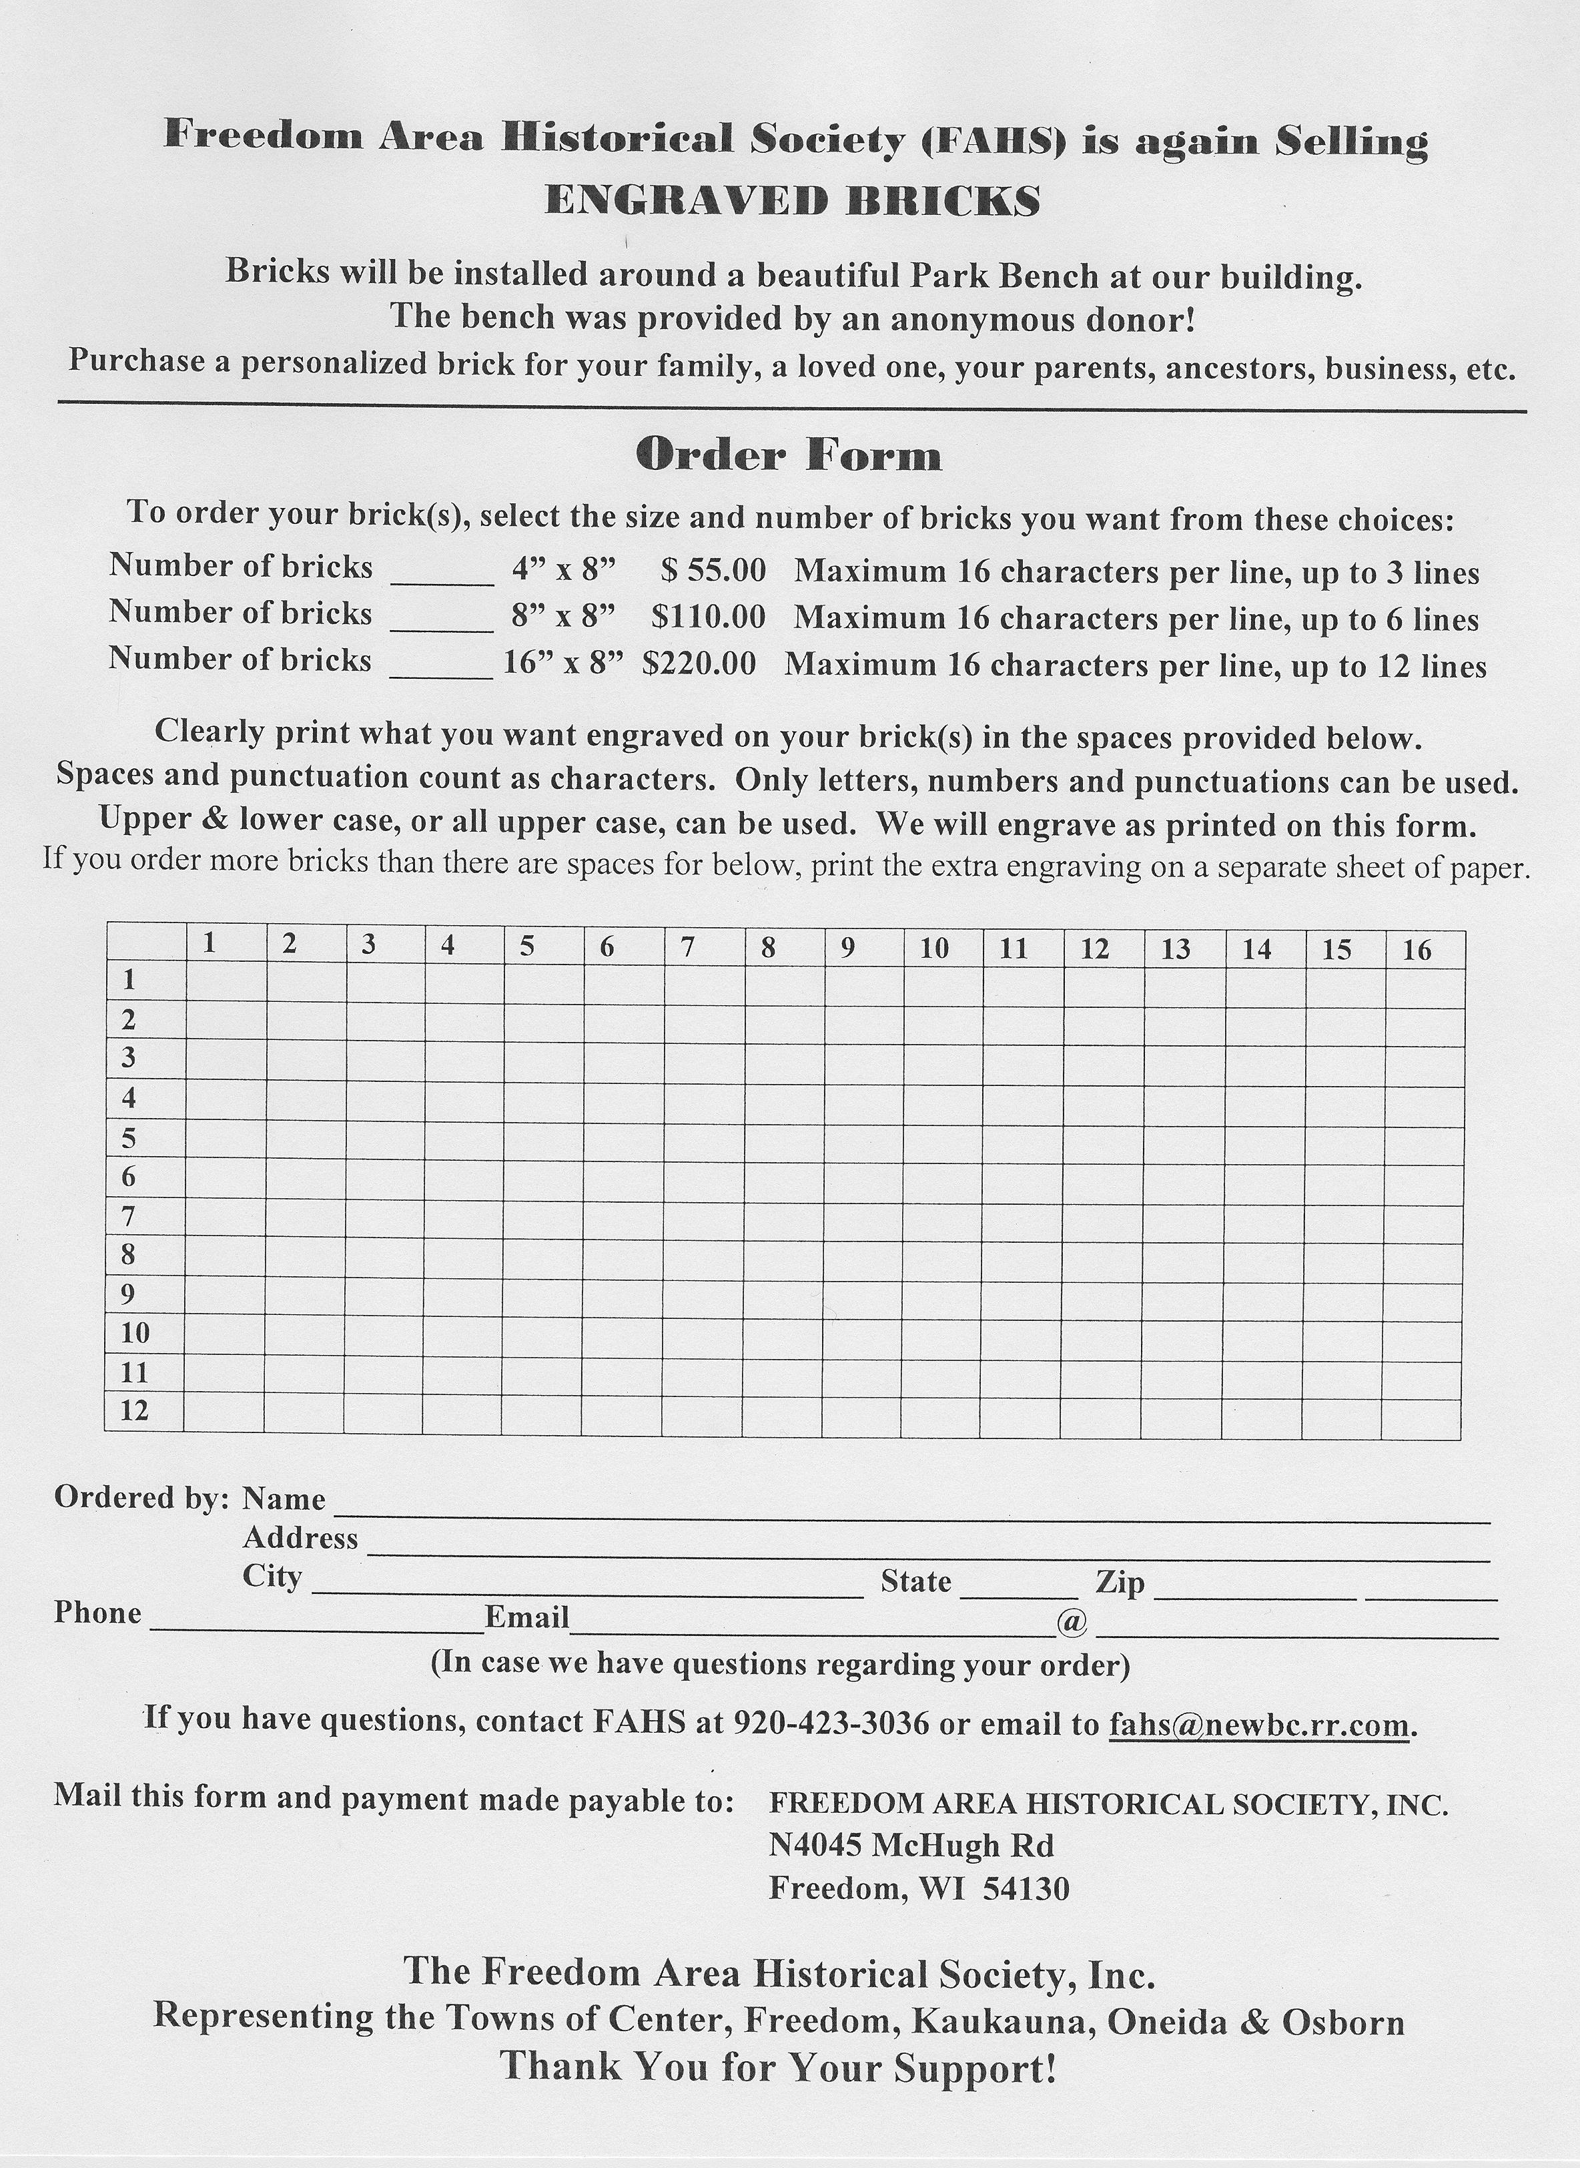

**MEMBERSHIP APPLICATION for FAHS**

Membership runs from January 1st through December 31st, except Lifetime

Date ____________________

**Name/s (include maiden name) ___________________________________________________________**

**Address _______________________________________________ City ___________________________**

**State ___________ Zip + 4 (if known) ___________________ Phone ______ - ________ - ___________**

**Email ________________________________________ @ ______________________________________**

**On the line below, list high school attended and year of graduation for each person listed above:**

______________________________________________________________________________________________

### Membership Levels – Annual Dues

#### Please check one Membership

**____ $ 10 Senior (individual 62 or older)**

**____ $ 10 Student (with school ID) Age ______**

**____ $ 15 Individual (under age 62)**

**____ $ 25 Family (one or more related adults and their dependent children)**

**List children _____________________________________________________________________**

**____ $ 100 Professional**

**____ $ 500 Lifetime (individual)**

**____ $ ______ Contributing Membership (wishing to pay more than normal dues-you choose the amount)**

**____ $ ______ Check here if you want to make a donation in addition to your membership dues**

**Are you interested in helping with activities/projects? _______Yes ______ No**

**Mail completed application and check to:**

**Freedom Area Historical Society, Inc.,**

**N4045 McHugh Rd**

**Freedom, WI 54130**

**2013 FAHS MEMBERS**

**Thank You for your Support**

**Carol Appleton - Jim & Dot Appleton-Lifetime Pam Ault**

**Contributing $25 Barbara Bell Ted & Liz Carpenter**

**Don & Jane Coffey John M Coffey Lois Colson-Contributing $25**

**Carole Derbique Duane Ebert Rose Ebben**

**Arlene Egan Mark & Mary Eggert-Family Gloria Farrell**

**Janice Faust Jean Fox Freedom Feed Mill-Lifetime**

**Gene Gonnering Germaine Green Pearl Green**

**Tom &Jeanne Greenwood Tom & Peg Greunke- Marv & Joann Haberland**

**Don & Donna Hameister- Contributing $25 Marian Hooyman**

**Family Phyllis Huelsbeck Anna Mae Huss**

**Mary Ellen Kavanaugh Harriet Kesler-Contributing $100 Steve & Pat Konkle**

**Vi Landwehr Karin Landwehr Gary Larocque**

**Oliver & Adeline Lerum Mary Lom-Contributing $50 Lois McMorrow-**

**Shari Nachtwey Dick & Carole Peters Contributing $35**

**Sister Sandy Peterson Shirley Primavera Rick & Cindy Pynenberg**

**Gene & Marg Randerson John Rickert Joseph Rickert**

**Roy & Vi Rickert- Pat & Mary Rickert- Rosemary Romenesko-**

**Contributing $40 Contributing $40 Lifetime**

**Ellen Schaetz Dennis Schaetz Glen & Dolly Schampers**

**Helen Schoettler Jerry & Bev Schuh Tony Schuh**

**Joan Semrow- Shelby Sigl Barb Smith-Contributing $50**

**Contributing $60 Irene Smith Jack & Ruthann Smith-Family**

**James & Shyla Smith-Family Tom Smith Fred Techlin**

**Norbert Techlin James & Janice Van Camp Arlene Vanden Boogart**

**Linda Van Den Bosch Helen Van Epern-Lifetime Gary & Bonnie Vander Loop-Rick & Ann Weyenberg- Alice Weyers Family Family Bill Weyers Bob & Tracy Weyers-Family Ron & Colleen Weyers-Lifetime**

***Do you have a Collection you would be willing to loan for a Display at the Historical Society? Call or visit us if you are interested!***

**FAHS is a non-profit corporation affiliated with the Wisconsin Historical Society. FAHS is a 501(c)(3) organization so your donations are tax deductible.**

**FAHS Board of Directors**

**President & Editor Pat Konkle**

**Vice President Jeanne Greenwood, Treasurer JoAnn Bowers**

**Secretary Linda Van Den Bosch**

**Directors: Margaret Ann Randerson, Mary Ellen Kavanaugh**

**and Marvin Haberland**